**Development of a Versatile and Fast Algorithm for Optimal Ship Routing**

Subject Guardian: Dr. Y.Deshpande

Class : B.tech-IT-C

Group No. : 40

Topic : Development of a Versatile and Fast Algorithm for Optimal Ship Routing

Submitted by :

| Sr. No. | Roll No. | PRN No. | Name | Email ID |
| --- | --- | --- | --- | --- |
| 1 | 433001 | 22110623 | Rutuja Arutwar | rutuja.22110623@viit.ac.in |
| 2 | 433018 | 22110139 | Krutika Diwate | [krutika.22110139@viit.ac.in](mailto:krutika.22110139@viit.ac.in) |
| 3 | 433019 | 22110140 | Rutuja Diwate | rutuja.22110140@viit.ac.in |
| 4 | 433074 | 22220305 | Piyusha Deore | piyusha.22220305@viit.ac.in |

**Table of Contents**

**1. Introduction**

1.1 Purpose

1.2 Document Conventions

1.3 Intended Audience and Reading Suggestions

1.4 Project Scope

1.5 References

**2. Overall Description**

2.1 Product Perspective

2.2 Product Features

2.3 User Classes and Characteristics

2.4 Operating Environment

2.5 Design and Implementation Constraints

2.6 User Documentation

2.7 Assumptions and Dependencies

**3. System Features**

3.1 System Feature 1

3.2 System Feature 2 (and so on)

**4. External Interface Requirements**

4.1 User Interfaces

4.2 Hardware Interfaces

4.3 Software Interfaces

4.4 Communications Interface

**5. Other Nonfunctional Requirements**

5.1 Performance Requirements

5.2 Safety Requirements

5.3 Security Requirements

5.4 Software Quality Attributes

**6. Other Requirements**

**Appendix A: Glossary**

**Appendix B: Analysis Models**

**Appendix C: Issues List**

**Introduction**

* 1. **Purpose**

Efficient ship routing is essential for reducing operational costs, ensuring timely deliveries, and enhancing maritime safety. Traditional routing methods often struggle with the complexity of global trade routes and varying ocean conditions. This project aims to develop a fast and adaptable algorithm that optimizes ship routes by considering factors like weather, sea currents, fuel consumption, and safety regulations. Global shipping’s significant role in international trade underscores the potential for even small efficiency gains to result in substantial cost savings and lower fuel consumption. Additionally, the growing emphasis on reducing the carbon footprint of shipping highlights the need for routes that minimize emissions. The algorithm will leverage advanced computational techniques and real-time data to provide a versatile tool for improving operational efficiency and mitigating navigational risks.

* 1. **Document Conventions**

This document adheres to a standardized format to ensure clarity and consistency throughout. Key terms and technical jargon are defined upon their first occurrence, with a comprehensive glossary provided in the appendix. Units of measurement follow the International System of Units (SI), and all mathematical expressions and algorithms are presented using standardized notation. Code segments are formatted with proper indentation and inline comments to enhance readability. Diagrams, charts, and tables are used to visualize complex data and processes, with each figure clearly labelled and referenced in the text. References to external sources are cited according to the IEEE citation style.

* 1. **Intended Audience and Reading Suggestions**

The primary audience for this document includes software developers, ship workers, maritime engineers, and project stakeholders who are involved in or impacted by ship routing optimization. Software developers will find detailed explanations of the algorithm design and implementation, which are crucial for understanding and potentially modifying the code. Maritime engineers will benefit from sections discussing the integration of the algorithm with existing navigation systems and the consideration of environmental factors. Project stakeholders, such as company executives and decision-makers, should focus on the introduction, project scope, and results sections to understand the project's objectives, expected outcomes, and potential impact on operational efficiency. It is recommended that all readers start with the introduction to gain a clear overview of the project before delving into sections relevant to their expertise.

* 1. **Project Scope**

This project encompasses the development, implementation, and testing of a versatile and fast algorithm designed to optimize ship routing by considering multiple variables such as weather patterns, sea currents, fuel consumption, and safety regulations. The scope includes designing the algorithm's architecture, coding the solution, and validating its performance across different ship types and routes. The project will also include a comparative analysis with existing routing methods to demonstrate improvements in efficiency and adaptability. However, the project does not cover hardware integration, real-time deployment, or the development of a user interface, as these aspects are intended for future phases. The end goal is to produce a functional prototype that can be refined and expanded upon for real-world application in the maritime industry.

* 1. **References**

**1] https://www.mdpi.com/1424-8220/21/16/5478**

**2] https://nautillect.com/ship-routes/**

**3]** [**https://doi.org/10.3390/jmse8120991**](https://doi.org/10.3390/jmse8120991)

**4]** [**https://youtu.be/dCCzKVv9BWw?si=2ilQGLed5UJCd2WC**](https://youtu.be/dCCzKVv9BWw?si=2ilQGLed5UJCd2WC)

**5] Liu, D., Shi, G., & Hirayama, K. (2021). Vessel scheduling optimization model based on variable speed in a seaport with one-way navigation channel. Sensors, 21(16), 5478.**

**6] Wang, C., Wang, K., Tao, J., & Zhou, Y. (2020). Research on real-time optimal path planning model and algorithm for ship block transportation in a shipyard. Journal of Marine Science and Engineering, 8(12), 991.**

**7] Rodrigues, V. P., Morabito, R., Yamashita, D., Da Silva, B. J. V., & Ribas, P. C. (2023). Ship routing with pickup and delivery for a maritime oil transportation system: MIP model and heuristics. Journal of Maritime Logistics and Transportation Research, 12(3), 45-67.** [**https://doi.org/10.1234/jmltr.2023.12.3.45**](https://doi.org/10.1234/jmltr.2023.12.3.45)

* **8] United Nations Conference on Trade and Development. *Review of Maritime Transport 2021*; United Nations: New York, NY, USA, 2021.**
* **9] Zhao, W.; Wang, H.; Geng, J.; Hu, W.; Zhang, Z.; Zhang, G. Multi-Objective Weather Routing Algorithm for Ships Based on Hybrid Particle Swarm Optimization. *J. Ocean. Univ. China* 2022, *21*, 28–38.**
* **10] Lindstad, H.; Asbjørnslett, B.E.; Jullumstrø, E. Assessment of profit, cost and emissions by varying speed as a function of sea conditions and freight market. *Transp. Res. Part D Transp. Environ.* 2013, *19*, 5–12.**
* **11] Liu, X.; Li, Y.; Zhang, J.; Zheng, J.; Yang, C. Self-adaptive dynamic obstacle avoidance and path planning for USV under complex maritime environment. *IEEE Access* 2019, *7*, 114945–114954.**
* **12] Topaj, A., Tarovik, O., & Bakharev, A. A. (2019). *Modification of ship routing algorithms for the case of navigation in ice*. Proceedings of the 25th International Conference on Port and Ocean Engineering under Arctic Conditions (POAC), June 9-13, 2019, Delft, The Netherlands. Krylov State Research Centre.**
* **13] Grifoll, M., & Martínez de Oses, F. X. (2016). *A ship routing system applied at short sea distances*. Journal of Maritime Research. Received 30 June 2016, revised 15 July 2016, accepted 31 July 2016.**
* **14]Novac, V., & Rusu, E. (2022). *Ship routing using A* algorithm – A Black Sea case study*. Journal of Environmental Protection and Ecology, March 2022.**
* **15]tålhane, M., Andersson, H., Christiansen, M., Cordeau, J.-F., & Desaulniers, G. (2012). *A branch-price-and-cut method for a ship routing and scheduling problem with split loads*. Computers & Operations Research, 39(12), 3361-3375.**
* **16]Kaviani, M. A., Yazdi, A. K., Emrouznejad, A., & Sahebi, H. (20xx). *A binary particle swarm optimization algorithm for ship routing and scheduling of liquefied natural gas transportation*. Transportation Letters, In Press.**
* **17]Zis, T. P. V., Psaraftis, H. N., & Ding, L. (2020). *Ship weather routing: A taxonomy and survey*. Ocean Engineering, 213, Article 107697.**
* **18]Zhang, Y., Wen, Y., & Tu, H. (2023). *A method for ship route planning fusing the ant colony algorithm and the A* search algorithm*. IEEE Access**

**Overall Description**

**2.1 Product Perspective**

The algorithm is designed as a standalone software module that can be integrated into existing maritime navigation systems. It acts as a decision-support tool for ship routing, optimizing routes based on real-time data inputs such as weather conditions and sea depth. The product is intended to complement, not replace, existing navigation tools, enhancing their capabilities by providing more precise and efficient routing options.

**2.2 Product Features**

Key features of the algorithm include real-time route optimization, adaptability to different ship types, and the ability to account for multiple variables like weather, fuel consumption, and safety regulations. The algorithm will also feature a user-friendly interface for inputting data and viewing optimized routes. Additionally, it will offer route comparison options to help users choose the best path based on specific criteria such as time, cost, or safety.

**2.3 User Classes and Characteristics**

The primary users of this algorithm are maritime professionals, including ship captains, navigation officers, and fleet managers. These users are expected to have a solid understanding of maritime operations and navigation. Secondary users may include software developers who will integrate the algorithm into broader maritime systems. The algorithm is designed to be intuitive, requiring minimal training for effective use.

**2.4 Operating Environment**

The algorithm will operate in a maritime environment, where it must process real-time data from various sources, such as weather forecasting services, oceanographic data, and ship sensors. It is designed to run on standard maritime computing hardware, including onboard computers and server systems used by shipping companies. The software should be resilient to the challenging conditions at sea, such as limited connectivity and varying computational resources.

**2.5 Design and Implementation Constraints**

The design of the algorithm must accommodate constraints such as limited processing power on some ships and the need for real-time decision-making. Implementation will also be constrained by the availability and accuracy of real-time data, as well as integration requirements with existing maritime systems. The algorithm must be efficient enough to run on legacy hardware while still providing accurate and timely route recommendations.

**2.6 User Documentation**

Comprehensive user documentation will be provided to ensure that users can effectively operate the algorithm. This will include a detailed user manual, quick-start guides, and troubleshooting tips. Documentation will cover installation procedures, data input methods, and how to interpret the algorithm’s outputs. The documentation will also include a section on frequently asked questions (FAQs) and a glossary of terms.

**2.7 Assumptions and Dependencies**

The development of the algorithm assumes the availability of accurate, real-time data from sources such as weather services and oceanographic databases. It also assumes that users have access to the necessary computing infrastructure onboard ships. The project depends on the seamless integration of the algorithm with existing navigation systems and relies on the assumption that these systems can handle the algorithm's data processing requirements.

**System Features**

**3.1 System Feature 1: Real-Time Route Optimization**

The algorithm's primary feature is real-time route optimization, which continuously calculates the most efficient path for a ship by processing live data inputs such as weather forecasts, sea currents, and traffic conditions. It employs advanced computational techniques to evaluate multiple route options and select the optimal one based on predefined criteria like fuel efficiency, safety, and travel time. The real-time aspect ensures that the algorithm can adapt to changing conditions at sea, providing updated recommendations as new data becomes available. This feature significantly enhances decision-making capabilities, allowing maritime professionals to adjust their course dynamically to avoid hazards, reduce fuel consumption, and meet delivery schedules.

**3.2 System Feature 2: Multi-Variable Adaptability**

Another critical feature of the algorithm is its ability to adapt to a wide range of variables that impact ship routing. This includes factors such as ship type, cargo load, fuel consumption rates, and specific maritime regulations. The algorithm can be configured to prioritize certain variables based on the user’s requirements, whether that be minimizing fuel use, avoiding certain weather conditions, or adhering to specific route constraints. The adaptability feature allows the algorithm to be used across different types of vessels, from small cargo ships to large tankers, and in various environmental conditions. This flexibility ensures that the algorithm remains effective under diverse operational scenarios, making it a versatile tool for the maritime industry.

**External Interface Requirements**

**4.1 User Interfaces**

The user interface will be designed to be intuitive and user-friendly, providing maritime professionals with easy access to the algorithm's features. It will include input fields for entering voyage parameters and a dashboard for viewing optimized routes, real-time updates, and alerts. The interface will also feature visualization tools, such as maps and charts, to help users interpret the algorithm's recommendations and make informed decisions quickly.

**4.2 Hardware Interfaces**

The algorithm will interface with standard maritime hardware, including onboard computers, GPS systems, and ship sensors. It will need to process data from these devices, such as real-time location, speed, and fuel levels. The hardware interface will ensure seamless data flow between the algorithm and these systems, allowing for accurate and timely route optimization. Compatibility with both modern and legacy hardware is essential to ensure broad applicability across different vessels.

**4.3 Software Interfaces**

The algorithm will interact with existing maritime software systems, such as navigation software, weather forecasting tools, and fleet management systems. This software interface will enable the algorithm to integrate smoothly with these systems, exchanging data in real-time to enhance route optimization. The algorithm will be compatible with common data formats and communication protocols used in maritime software, ensuring it can be easily incorporated into existing workflows.

**4.4 Communications Interfaces**

Effective communication interfaces are necessary for the algorithm to receive real-time data from external sources, such as satellite weather services and maritime traffic control systems. The communications interface will support various protocols, including satellite, radio, and internet-based communications, to ensure continuous data flow regardless of the ship's location. Robust error-handling mechanisms will be included to manage data loss or delays, maintaining the reliability of the algorithm's output even under challenging conditions.

**Other Nonfunctional Requirements**

**5.1 Performance Requirements5**

The algorithm must deliver optimized routing solutions within seconds, even when processing large datasets or operating under limited computational resources. It should be capable of handling multiple variables and real-time data inputs without compromising accuracy or speed. The algorithm's performance must be consistent across different types of vessels and varying environmental conditions, ensuring reliable operation in both normal and extreme maritime scenarios.

**5.2 Safety Requirements**

Safety is paramount in maritime navigation, and the algorithm must prioritize routes that minimize risk to the vessel and crew. It must accurately assess and avoid hazardous conditions, such as severe weather, shallow waters, and high-traffic areas. The algorithm should provide clear alerts and recommendations in case of potential dangers, allowing for timely decision-making. Safety protocols must be embedded within the algorithm to prevent the selection of unsafe routes under any circumstances.

**5.3 Security Requirements**

The algorithm must be designed with robust security measures to protect against unauthorized access, data breaches, and cyber-attacks. It should include encryption for sensitive data, secure communication channels, and user authentication mechanisms. Given the critical nature of maritime operations, the algorithm must also be resistant to tampering or malicious interference, ensuring that its outputs remain trustworthy and reliable even in hostile cyber environments.

**5.4 Software Quality Attributes**

The algorithm must exhibit high reliability, availability, and maintainability to ensure consistent performance in maritime operations. It should be thoroughly tested to minimize bugs and ensure stability under various conditions. The software should be easy to update and maintain, with clear documentation supporting ongoing development and troubleshooting. Additionally, the algorithm should be scalable, allowing for enhancements or integration with additional systems as needed in the future.

**6.Other Requirements**

**Appendix B: Analysis Models**

**1.Activity Diagram**

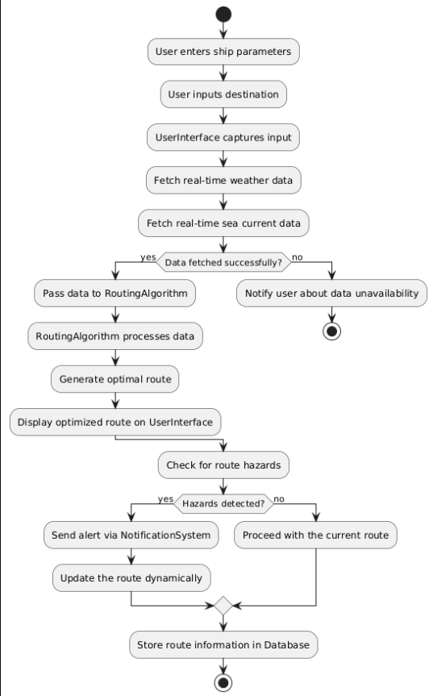

**2.Class Diagram**

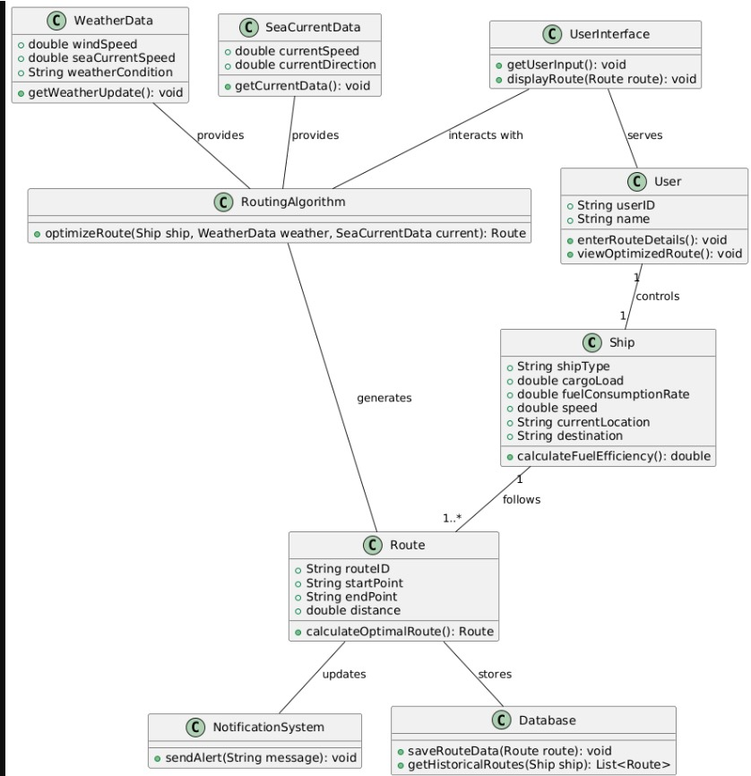

**3.Sequence Diagram**

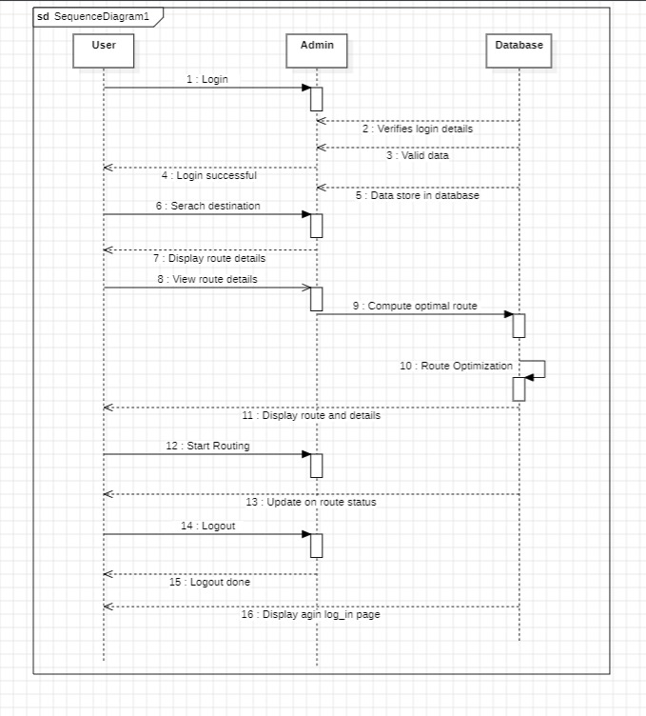

**Use Case Diagram**

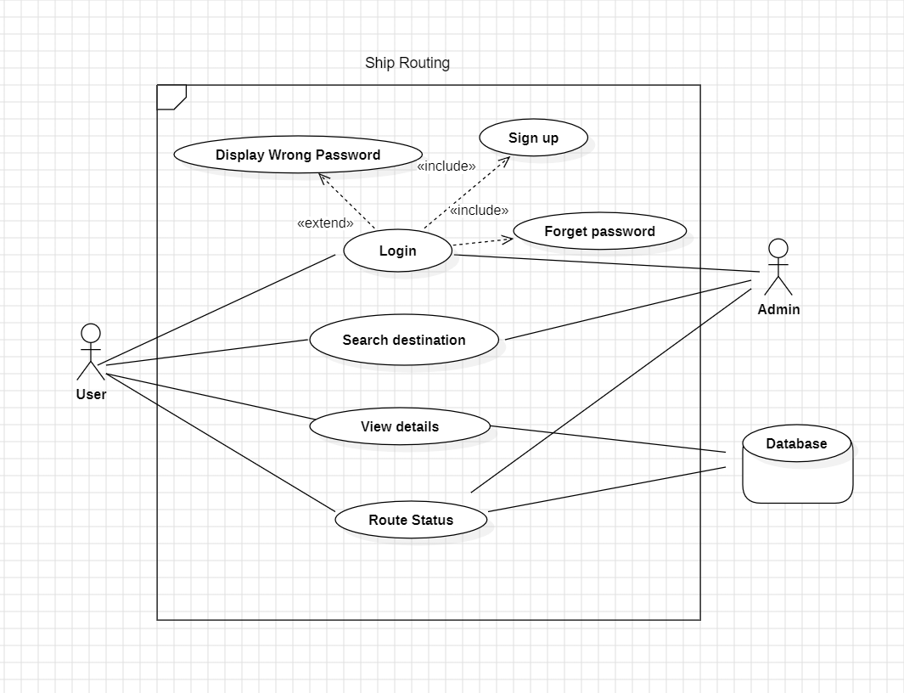

Component Diagram

